EFTCO Guideline: CO₂ emission calculation for tank cleaning.

1) Introduction.
The European authorities asked the chemical industry to calculate the CO₂ emissions of the logistic services they uses. The transport service is important in these emissions, but also tank cleaning is a part of the logistic service. For this reason an emission section is integrated in the SQAS 2022 and updated in the SQAS 2025 Tank cleaning questionnaire.
EFTCO prepared this guideline to help the tank cleaning stations with the calculation of these emissions to make sure this is done in a correct way. The purpose of these calculations is to make the sector aware of their CO₂ emissions, to motivate them to reduce them and to show the result to the (interested) customers and / or the public.

2) Terminology used.
Some terminology was originally created for the transport sector, but the same terms are also used for our sector to keep the comparison between the logistics sectors:
- Well To Tank (WTT)
the CO₂ emission of the energy between the well and the tank of a truck. In our sector it is the emission until the energy is arriving in our company before it is used. WTT is the only CO₂ emission for electricity because the consumption of it is not producing more CO₂
- Tank To Wheel (TTW)
The fuel or gas burned in your installation. This includes the fuel burned for boilers, forklifts, terrain trucks, incinerators, …
- Well To Wheel (WTW)
The sum of WTT and TTW
- Emission intensity:
In our sector it is the total CO₂ emission (WTW) in a year produced by your cleaning and heating activities divided by the sum of the number of cleanings and heating in the same year
- GLEC framework :
Global Logisitcs Emissions Council Framework for Logistics Emissions Accounting and Reporting. This framework contains CO₂ emissions factors of different energies used in different activities and countries. Mainly the WTT emission factor for electricity can differ from country to country depending on the manner the electricity is produced (wind energy, waterpower energy, nuclear energy, coal, gas, …).

3) Example calculation for the total CO₂ emission of :

The example calculation below used the CO₂ emission factors published by GLEC:
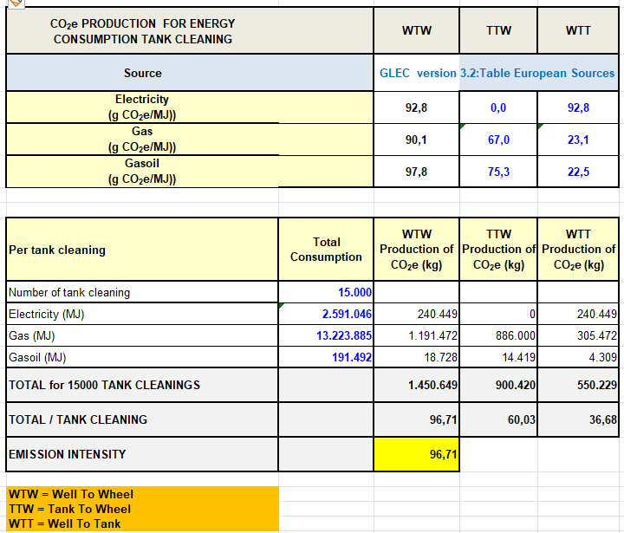
Please take care that you use the same units as these of the emission factors. Use the conversion table below when this is not the case:
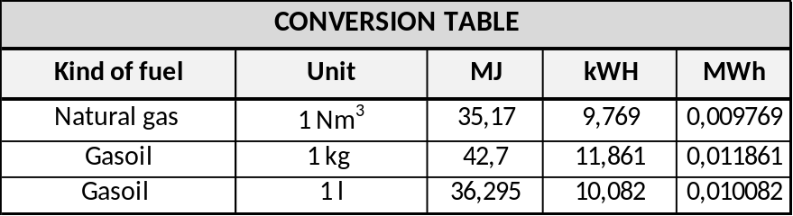
The emission factors can be different from country to country. Therefore this calculation is not meant to compare countries or individual installations with each other. By repeating this calculation each year, a company can proof It’s effort to reduce it’s CO₂ emission intensity by reducing the total energy consumption per cleaning, changing to an energy source with a lower CO₂ emission, renewal of older burners, ….
PS.: the Excel calculation model is available for the members on the EFTCO website.
4) Calculation of the CO2 emission during the heating of a loaded tank
Heating of a loaded tank is often part of the logistic chain. Therefore it is to be expected that transport companies ware going to ask their heating company what the CO₂ emission was for the heating of their tank.
When you company is able to register separately the energy consumption for a certain heating place, these consumptions can be put in the spreadsheet mentioned under previous point 3 where the number of cleaning is put to zero and the number of heating’s to 1. This will give you the CO2 emission for the heating of the tank.
In case you do no have a separate registration for the energy consumed during your heating activity, another method needs to be found.
In most cases the time that the steam valve to the tank is open is registered or known by the operator and based on this a calculation can be made of the steam consumed and the CO₂ emissions produced.
To help you with this calculation EFTCO created a spreadsheet which could be helpful.
- All blue figures which are yellow marked, are the only fields changeable for the user
- The other fields are protected to avoid problems with the formulas.
Following Fields can be changed by the user, some of the only oncer or from time to time:
- CO₂ emission steam heating / MJ: The value 90,1 g CO₂/MJ comes from GLEC, but it is possible that the value is not the same in your region. Please adapt accordingly.
- Working pressure steam: this pressure can be changed in function of the work pressure of the tank or for quality reasons. Please fill in the atmospheric pressure, the model will calculate the absolute pressure.
- Condensate collected per hour steaming: this gives you an idea of the amount of steam consumed per hour For most steaming places this will be a value between 150 and 250 kg. Please make sure the steam valve was continuously open during this measurement
- The temperature of the condensate collected (in case of recuperation). Please put 0 here when the condensate is lost.
- Hours of steaming during heating: the total hours the steam valve was open from the connection until the disconnection of the tank. The steaming hours can be less then the time that a tank blocked your heating place, because it is often picked up later by the customer.
- Efficiency boiler heating station: Thus efficiency can be higher or lower depending on the age of the burner of your boiler.
On the next page you find an example of this calculation. The steam valve was open for 10,50 hour, 4314,78 MJ was consumed resulting in an CO₂ emission of 388,762 kg.
The calculation model in Excel is available for the members on the EFTCO Website.

5) Example calculation for the total CO₂ emission of steam heating:

The example calculation below used the CO₂ emission factor according GLEC
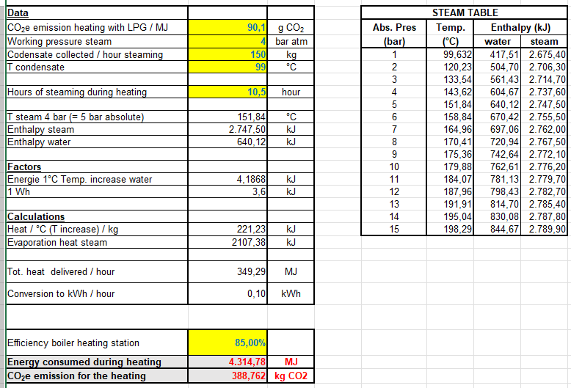

PS: The Excel calculation is available for download

